150907-5252-0751





I spent my first 20 years growing up in the City of Gosnells and have been here again for the last five. I am married, have grown children and was a career academic – in the fields of politics and applied policy. My last ten years of university employment were spent at the Institute for Sustainability and Technology Policy at Murdoch researching and teaching postgraduate courses in city planning and development theory. Though retired, I continue to write and have become a small-scale land developer. Now it’s hands-on urban development!

Major Issues of concern to me include

1. **Urban consolidation:** the State Government’s strategic plan – Directions 2031 and Beyond – for the and its infill development threatening the quality of life in middle and outer suburbs across Perth, especially the Albany Highway corridor. **more**
2. **Housing affordability:** It well known that home ownership is increasingly beyond the reach of younger lower income households of the kind that might once have settled more easily in the City of Gosnells. **more**
3. **Public service:** The 640+ employees of the City of Gosnells are our local public servants and they are mostly doing an excellent job. **more**
4. **Cleaning and greening public space:**  streets, parks and carparks. **more.**

**Housing Affordability**

It is well known that home ownership is increasingly beyond the reach of younger lower income households of the kind that might once have settled more easily in the City (though housing stress is rising for all ages[1]) . WA has also registered the greatest decline in home ownership rates in recent years.

**HOME OWNERSHIP RATES(a) BY STATE AND TERRITORY - 2006 and 2011**

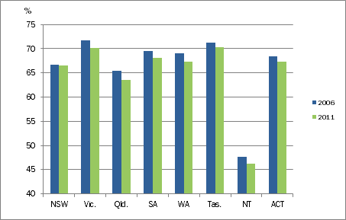

Source: ABS Census of Population and Housing, 2006 and 2011

 Local authorities may be limited in what they can do about housing costs but they are far from powerless. Worldwide, strategies supporting relevant innovation (whether design, building, finance or management innovation) initiated by municipal authorities include:

* direct land and property development
* joint venturing with partners committed to constructive innovation – where partners might include other government agencies, technical and tertiary education institutions, community and not-for-profit housing associations, charitable foundations and the private sector
* innovative demonstration projects
* facilitation of innovation through research, professional development and information dissemination - see report on “Making apartments affordable: moving from speculative to deliberative development” at Australian Policy Online, for example. <http://apo.org.au/research/making-apartments-affordable-moving-speculative-deliberative-development>

**If elected to Council, I will propose that the City moves, if only modestly, to take some initiatives in this important area.**

**Public service**

1. The 640+ employees of the City are our local public servants and they generally do an excellent job. Good organisations, however, are committed to ongoing review and improvement. All individual City employees will be subject to formal ongoing performance review but I don’t know whether or how well the City’s administration reviews itself corporately against its mission statement and principle strategies. Perhaps the Council needs to involve itself more closely in this process. After all, the elected Councillors are the direct representatives of the people… and the people are the boss.
2. As a property developer, I often have occasion to correspond or deal directly with staff and, if I have any issues, they relate to the (uncertain) time sometimes taken for responses to inquiries. Substantive decisions can take time, especially if workloads are heavy but there are better and worse ways of managing such problems. Those, like myself, making written or email inquiries should have their correspondence acknowledged immediately and be given indications of how long decisions or answers will take. (Many such responses can even be automated with good digital systems.) This is both good management practice, courtesy and a demonstration of respect for those paying the wage and salary bill. The boss, again, in other words.
3. As well as courtesy, friendliness and patience over the counter are also good practice, Those who come to the counter are usually there because they know less than those behind the counter. It helps to remember that. They may be the boss but staff are paid to be repositories of information and expertise. Staff may be the experts but they are still the servants.

**I will watch over these matters if I am elected to Council.**

**Cleaning and greening public space: streets, parks and carparks**

This litter is not just an eyesore. Three-quarters of it is plastic and just 400 metres downstream, this drain discharges into the Canning River where its serious work of choking and poisoning riverine life begins. From there, it’s on to the Swan River and Indian Ocean…

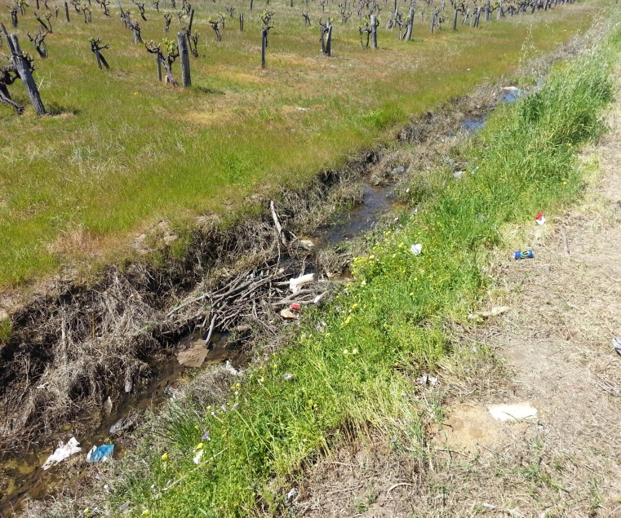

**Facts about plastic waste**

46 percent of plastics float and it can drift for years before eventually concentrating in the ocean gyres.

The Great Pacific Garbage Patch is located in the North Pacific .. and is the largest ocean garbage site in the world. – twice the size of Texas. Plastic pieces outnumbering sea life six to one.

Enough plastic is thrown away each year to circle the earth four times.

Australians may be throwing 3 billion plastic away water bottles every year.

Annually approximately 500 billion plastic bags are used worldwide.

It takes 500-1,000 years for plastic to degrade.

http://ecowatch.com/2014/04/07/22-facts-plastic-

pollution-10-things-can-do-about-it/

There are not enough trees in the oceanic car park shown below, There are no bins in the Maddington Centro carpark either! And litter often blows on to adjacent streets. The City has the power to remedy these problems wherever they occur and it’s not just Maddington Centro, I’m not sure why the will is lacking. **If I’m elected to Council, I’ll look into it.**

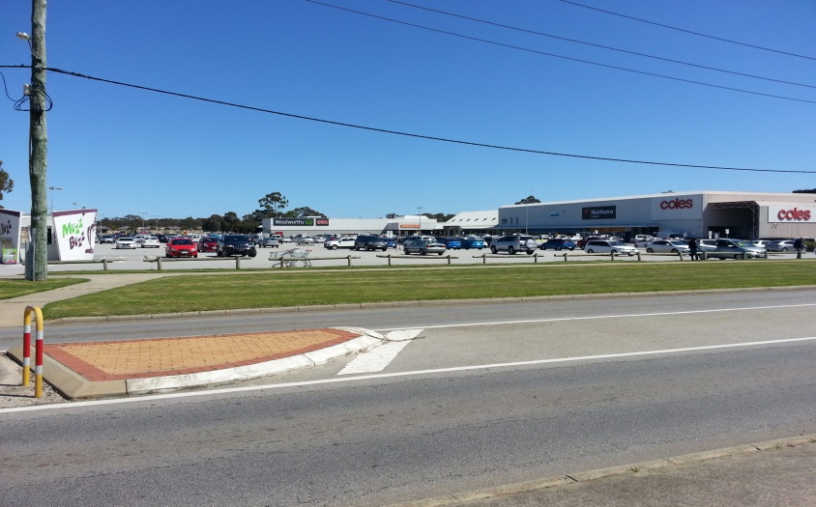

**Maddington Centro Car Park**

1. <http://www.ahuri.edu.au/downloads/publications/EvRevReports/AHURI_Final_Report_No192_Housing_affordability_housing_stress_and_household_wellbeing_in_Australia.pdf> p 44.